CAPSTONE PROJECT – Smart Home

ADITHIYAN RAJAN

Description

LDR Sensor detects change in light intensity. Used to switch on the room lights (blue LED) when the sunlight is low – can be replaced with force sensor, flex sensor according to need and application

Ultrasonic sensor detects presence of object. Used to open the door, here indicated by the servo motor, if the is an object close by.

PIR sensor (motion detector) detects motion. Used in rooms, corridors, staircases etc. to switch on lights when motion is detected.

Temperature sensor measures and returns temperature. Used here to turn on the fan or ac, here indicated by red LED, when temperature gets too high.

Gas detector detects if there is smoke. Used to set of alarm, here piezo, if the smoke is above a certain threshold.

Circuit

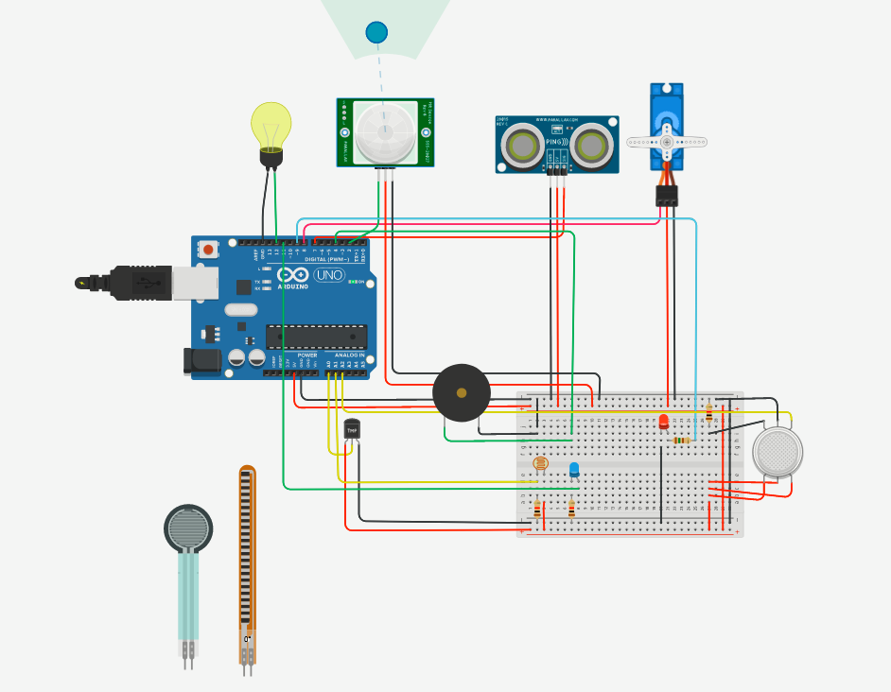

CODE

#include <Servo.h>

int dist = 0;

int light =0;

int gas =0;

long readUltrasonicDistance(int triggerPin, int echoPin)

{

pinMode(triggerPin, OUTPUT); // Clear the trigger

digitalWrite(triggerPin, LOW);

delayMicroseconds(2);

// Sets the trigger pin to HIGH state for 10 microseconds

digitalWrite(triggerPin, HIGH);

delayMicroseconds(10);

digitalWrite(triggerPin, LOW);

pinMode(echoPin, INPUT);

// Reads the echo pin, and returns the sound wave travel time in microseconds

return pulseIn(echoPin, HIGH);

}

Servo servo_8;

void setup()

{

servo_8.attach(8, 500, 2500);

pinMode(2, INPUT);

pinMode(12, OUTPUT); // blub

pinMode(A0, INPUT);

pinMode(A2, INPUT); // smoke dec

pinMode(9, OUTPUT); // red led

pinMode(11, OUTPUT); //white led - room light

pinMode(4, OUTPUT); // piezo

}

void loop()

{

dist = 0.01723 * readUltrasonicDistance(7, 7);

if (dist <= 100) {

servo_8.write(90);

delay(500); // Wait for 1000 millisecond(s)

} else {

servo_8.write(0);

delay(500); // Wait for 1000 millisecond(s)

}

if (digitalRead(2) == 1) {

digitalWrite(12, HIGH);

delay(500); // Wait for 1000 millisecond(s)

} else {

digitalWrite(12, LOW);

delay(500); // Wait for 1000 millisecond(s)

}

if (analogRead(A0) > 200) {

digitalWrite(9, HIGH);

delay(500); // Wait for 1000 millisecond(s)

} else {

digitalWrite(9, LOW);

delay(500); // Wait for 1000 millisecond(s)

}

light = analogRead(A1);

analogWrite(11,map(light,1023,0,0,255));

gas = analogRead(A2);

if (gas > 250) {

digitalWrite(4, HIGH);

delay(500); // Wait for 1000 millisecond(s)

} else {

digitalWrite(4, LOW);

delay(500); // Wait for 1000 millisecond(s)

}

}